## Duplicating Objects and Styles

RapidPlan has made it simple to duplicate objects and/or an items property onto another item.

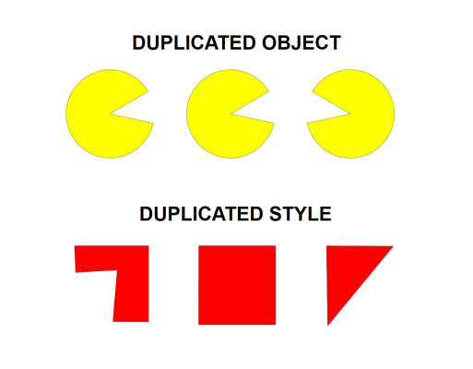

Duplicate_Object_and_Duplicate_Style